IDS 401

# Assignment 5

Adapt your application from the previous Assignment 4 and convert it to a GUI application. The class name should be Checking5, an underscore, and your NetID run together; for example, if your NetID is abcde6, your class name would be Checking5_abcde6. For this assignment, we will create GUI-based tools for creating, and searching Checking objects. Unless overridden, all requirements from the previous assignment remain in effect. We will work step by step in the following assignments.

Unless stated otherwise, all requirements from the previous assignment remain in effect. Instead of entering data from console, we now enter data from GUI. Below is an example of how this program should look like.

Step 1: when you run the program something like this should pop up:

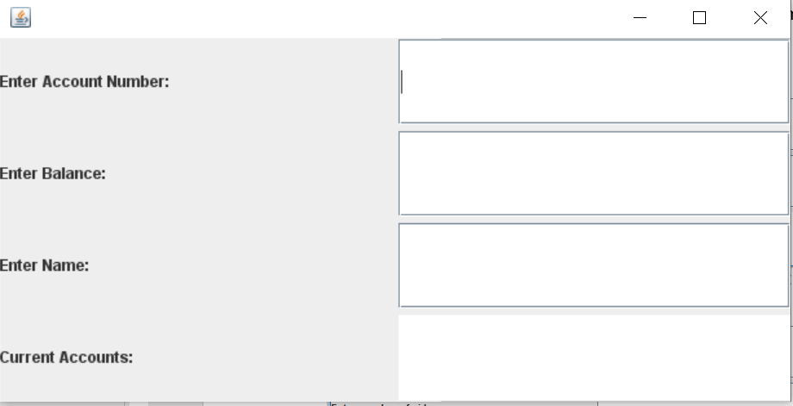

Step 2: Now I enter “1” in the text field after “Enter account number:”, “100” after “Enter balance: ”, “Superman” after ”Enter Name:”.

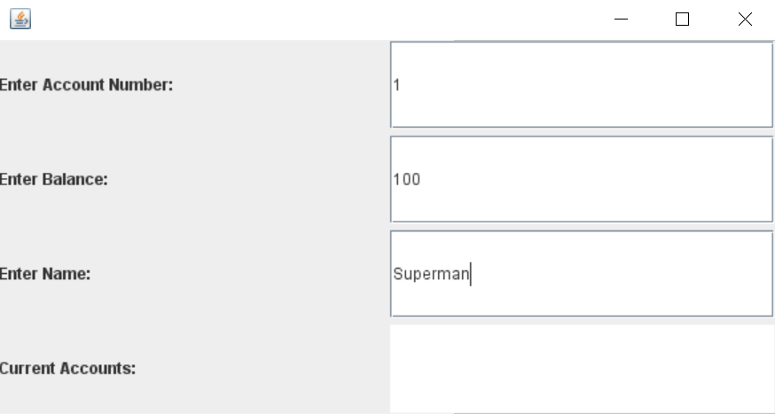

Step 3: Then I press Enter key on keyboard. You can see in “Current Accounts”, it shows the information of the account I just entered. Notice that it is up to you what you want to do with the first three textfields after you press Enter. I chose to reset the value of these three boxes to empty string.

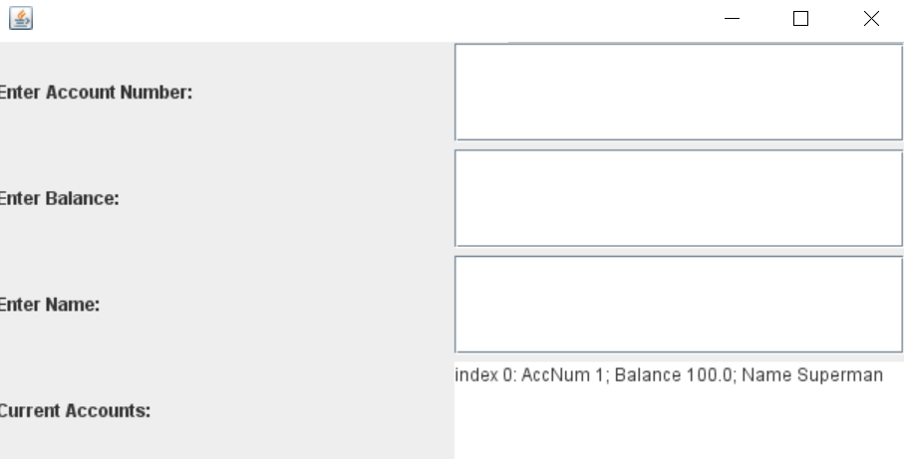

Step 4: Now I can enter the second account information:

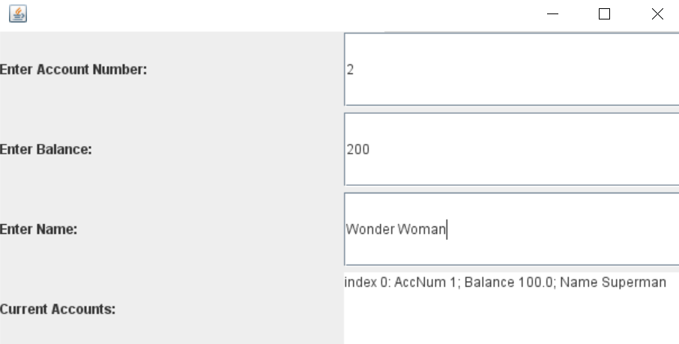

And press Enter. Now “Current Accounts” is displaying two accounts information.

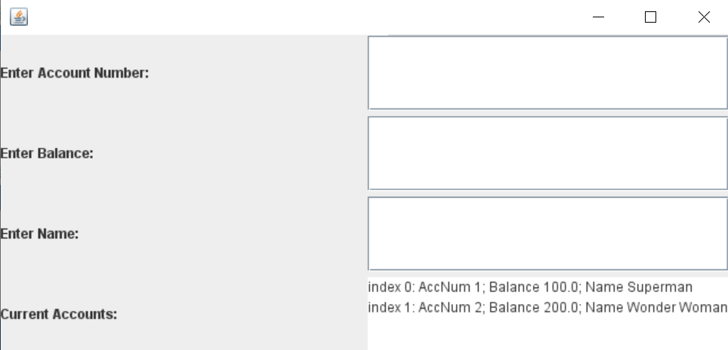

I used GridLayout in this example. You can choose your own layout